ASDM

ASSINGMENT 2

NAME :- ATTARDE SANKET

Web Application On Jira Software

Software name :- Flipkart

HOME PAGE:-

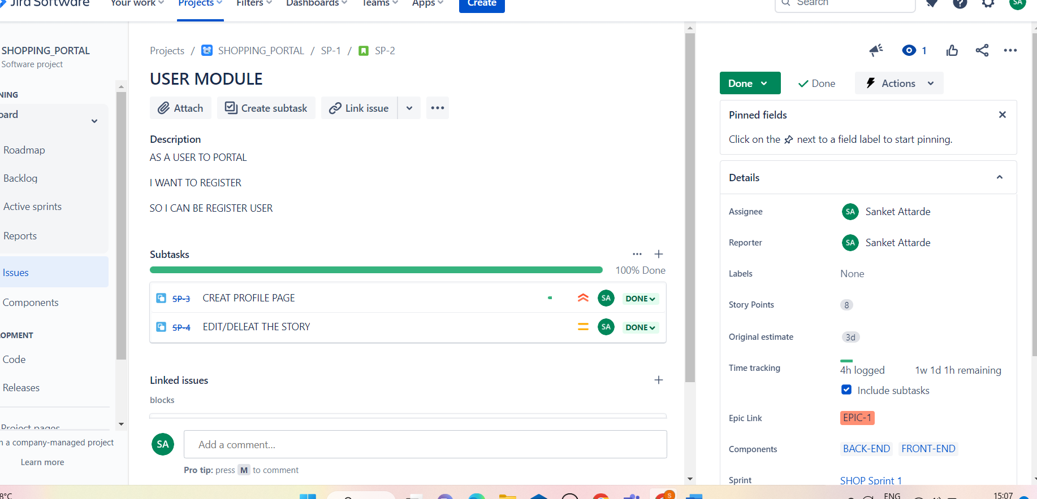

BACKLOG:-

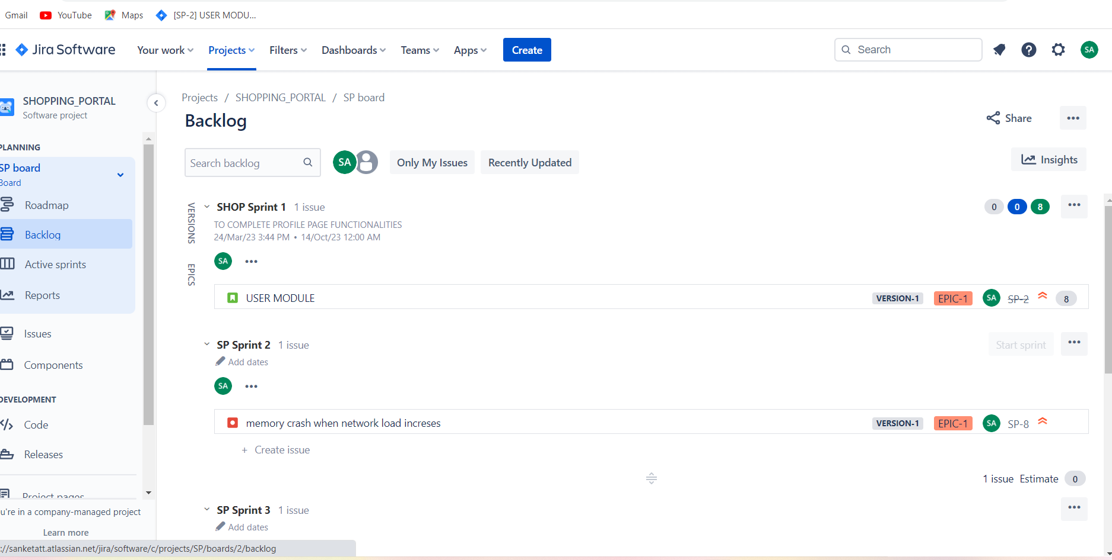

ACTIVE SPRINT:-

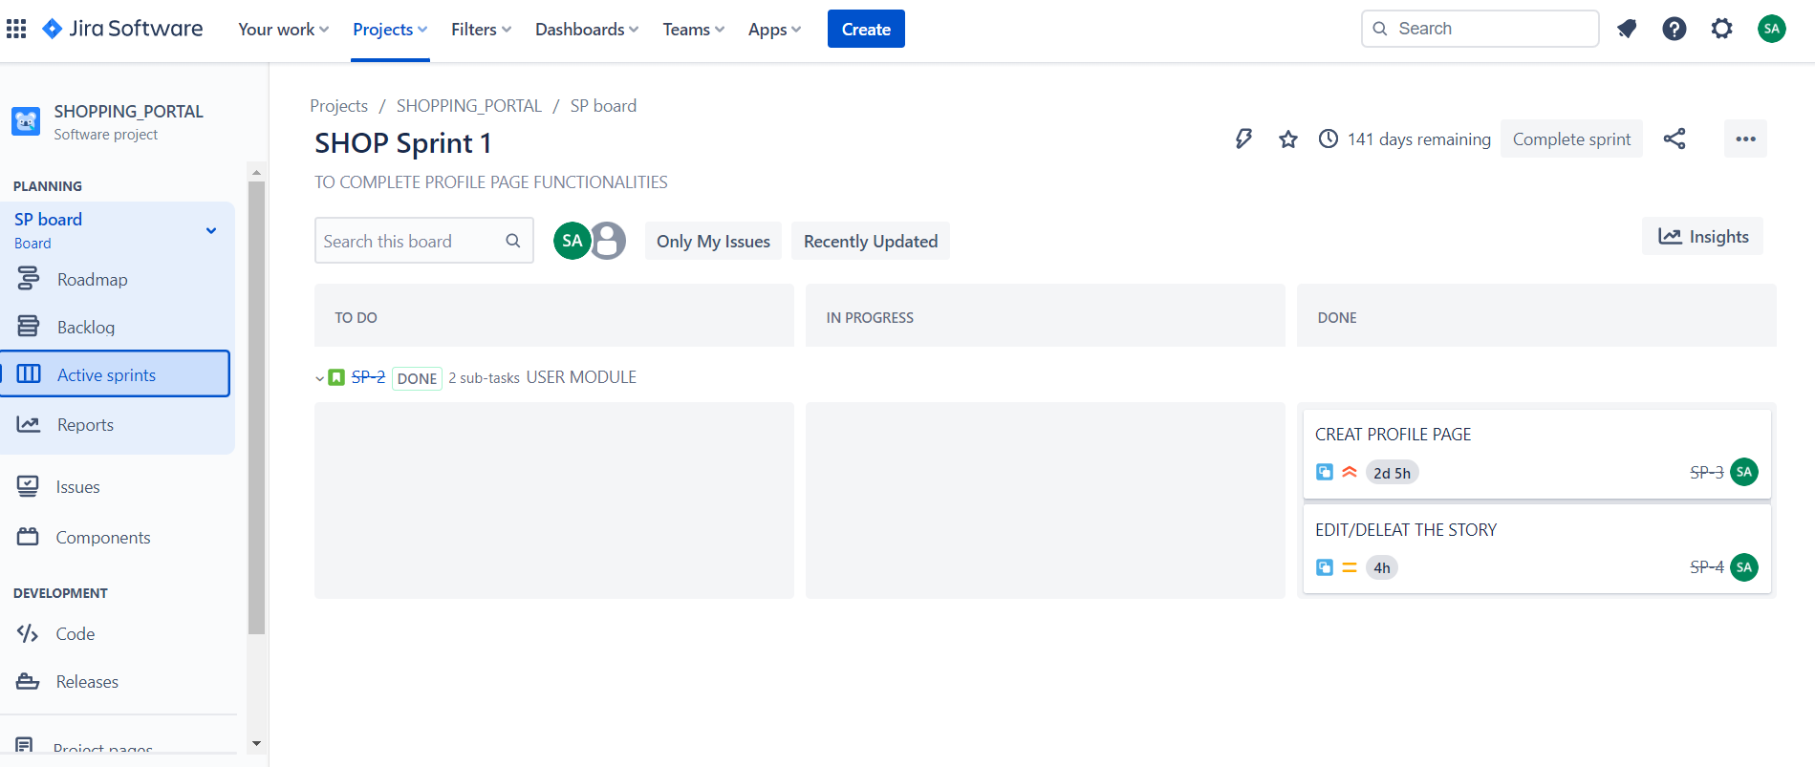

CHART:-

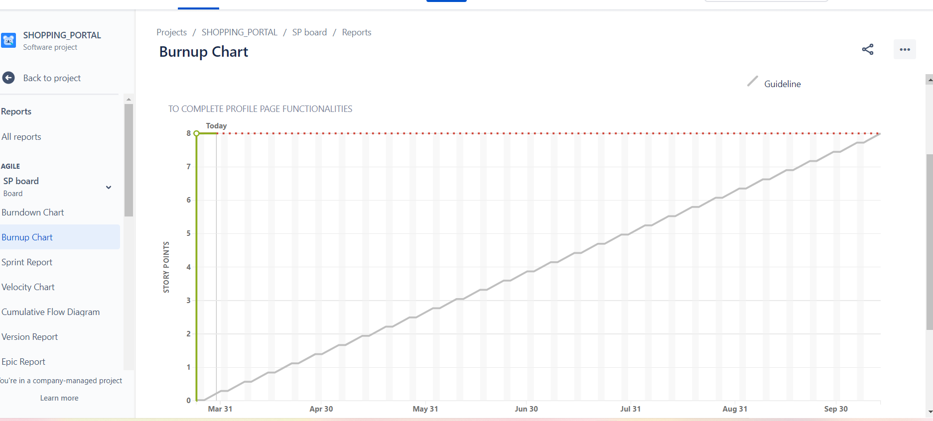

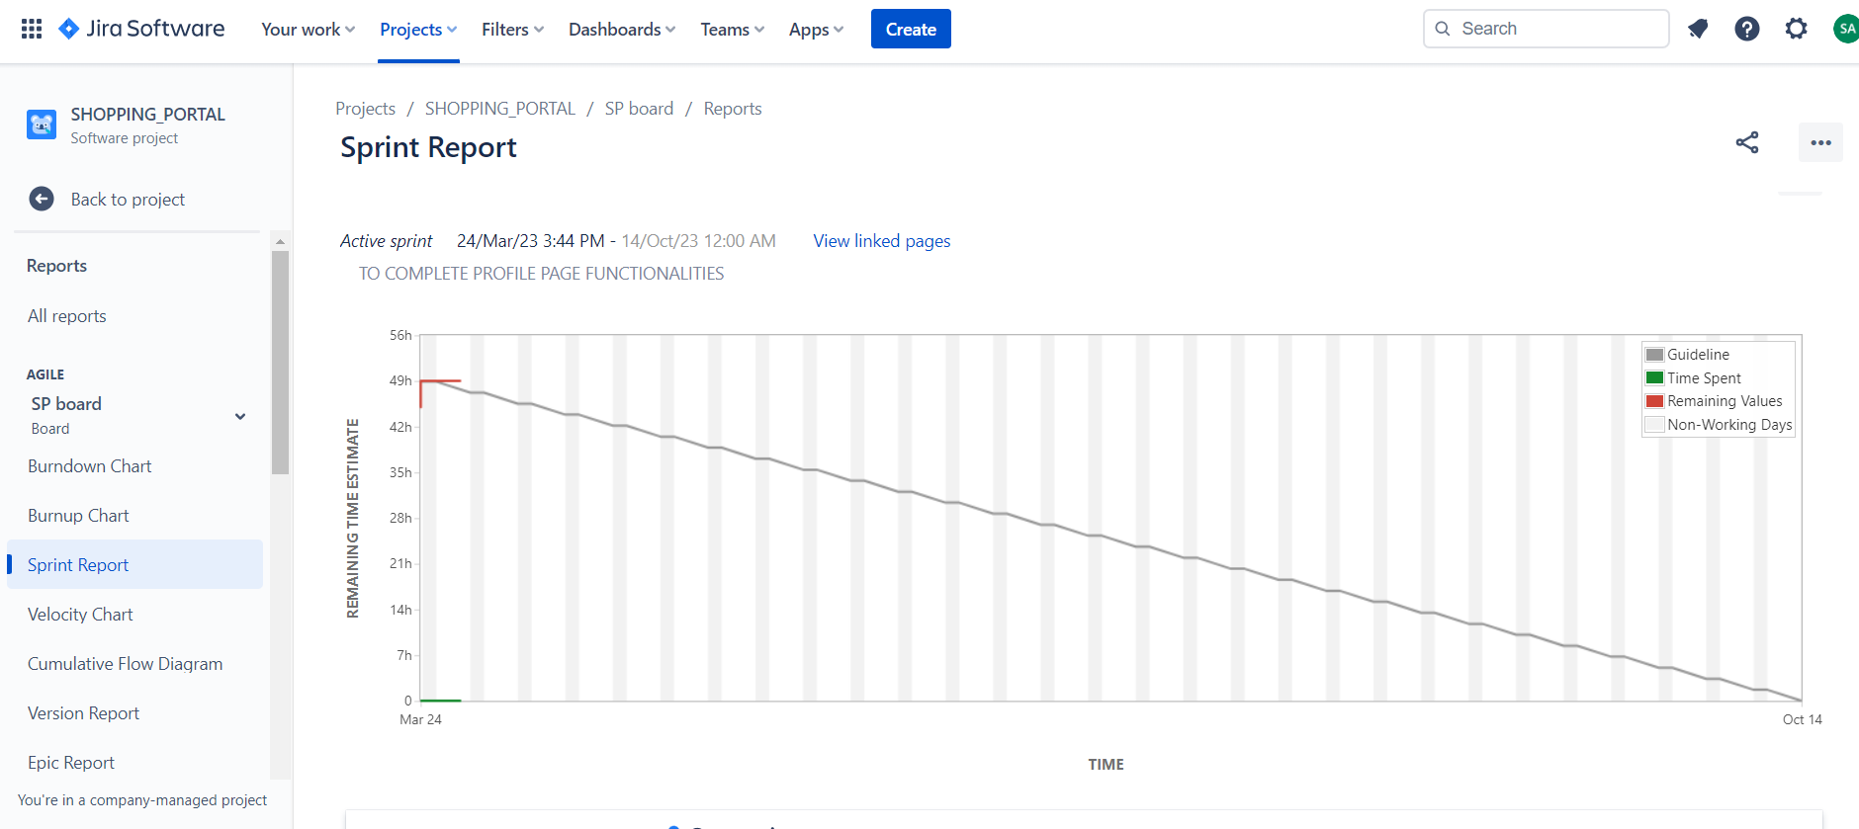

SPRINT:-

